abeille
 | a | b | c | d | e | f | g | h | i | j | k | l | m | n | o | p | q | r | s | t
1
2
3
4
5
6
7
8
9
10
11
12
13
14
15
16
17
18
19
20
21
22
23
24
25
26
27
28
29
30
31
32
33
34
tulipe
 | a | b | c | d | e | f | g | h | i | j | k | l | m | n | o | p | q | r | s | t
1
2
3
4
5
6
7
8
9
10
11
12
13
14
15
16
17
18
19
20
21
22
23
24
25
26
27
28
29
30
31
32
33
34

fraise
 | a | b | c | d | e | f | g | h | i | j | k | l | m | n | o | p | q | r | s | t
1
2
3
4
5
6
7
8
9
10
11
12
13
14
15
16
17
18
19
20
21
22
23
24
25
26
27
28
29
30
31
32
33
34
cerises
 | a | b | c | d | e | f | g | h | i | j | k | l | m | n | o | p | q | r | s | t
1
2
3
4
5
6
7
8
9
10
11
12
13
14
15
16
17
18
19
20
21
22
23
24
25
26
27
28
29
30
31
32
33
34

jonquille
 | a | b | c | d | e | f | g | h | i | j | k | l | m | n | o | p | q | r | s | t
1
2
3
4
5
6
7
8
9
10
11
12
13
14
15
16
17
18
19
20
21
22
23
24
25
26
27
28
29
30
31
32
33
34
pensée
 | a | b | c | d | e | f | g | h | i | j | k | l | m | n | o | p | q | r | s | t
1
2
3
4
5
6
7
8
9
10
11
12
13
14
15
16
17
18
19
20
21
22
23
24
25
26
27
28
29
30
31
32
33
34

coccinelle 1
 | a | b | c | d | e | f | g | h | i | j | k | l | m | n | o | p | q | r | s | t
1
2
3
4
5
6
7
8
9
10
11
12
13
14
15
16
17
18
19
20
21
22
23
24
25
26
27
28
29
30
31
32
33
34
papillon 1
 |  | a | b | c | d | e | f | g | h | i | j | k | l | m | n | o | p | q | r | s
1
2
3
4
5
6
7
8
9
10
11
12
13
14
15
16
17
18
19
20
21
22
23
24
25
26
27
28
29
30
31
32
33
34

poussin
 | a | b | c | d | e | f | g | h | i | j | k | l | m | n | o | p | q | r | s | t
1
2
3
4
5
6
7
8
9
10
11
12
13
14
15
16
17
18
19
20
21
22
23
24
25
26
27
28
29
30
31
32
33
34
bourdon
 | a | b | c | d | e | f | g | h | i | j | k | l | m | n | o | p | q | r | s | t
1
2
3
4
5
6
7
8
9
10
11
12
13
14
15
16
17
18
19
20
21
22
23
24
25
26
27
28
29
30
31
32
33
34

carotte
 | a | b | c | d | e | f | g | h | i | j | k | l | m | n | o | p | q | r | s | t
1
2
3
4
5
6
7
8
9
10
11
12
13
14
15
16
17
18
19
20
21
22
23
24
25
26
27
28
29
30
31
32
33
34
radis
 | a | b | c | d | e | f | g | h | i | j | k | l | m | n | o | p | q | r | s | t
1
2
3
4
5
6
7
8
9
10
11
12
13
14
15
16
17
18
19
20
21
22
23
24
25
26
27
28
29
30
31
32
33
34

escargot
 | a | b | c | d | e | f | g | h | i | j | k | l | m | n | o | p | q | r | s | t
1
2
3
4
5
6
7
8
9
10
11
12
13
14
15
16
17
18
19
20
21
22
23
24
25
26
27
28
29
30
31
32
33
34
veau
 | a | b | c | d | e | f | g | h | i | j | k | l | m | n | o | p | q | r | s | t
1
2
3
4
5
6
7
8
9
10
11
12
13
14
15
16
17
18
19
20
21
22
23
24
25
26
27
28
29
30
31
32
33
34

coccinelle 2
 | a | b | c | d | e | f | g | h | i | j | k | l | m | n | o | p | q | r | s | t
1
2
3
4
5
6
7
8
9
10
11
12
13
14
15
16
17
18
19
20
21
22
23
24
25
26
27
28
29
30
31
32
33
34
chenille
 | a | b | c | d | e | f | g | h | i | j | k | l | m | n | o | p | q | r | s | t
1
2
3
4
5
6
7
8
9
10
11
12
13
14
15
16
17
18
19
20
21
22
23
24
25
26
27
28
29
30
31
32
33
34

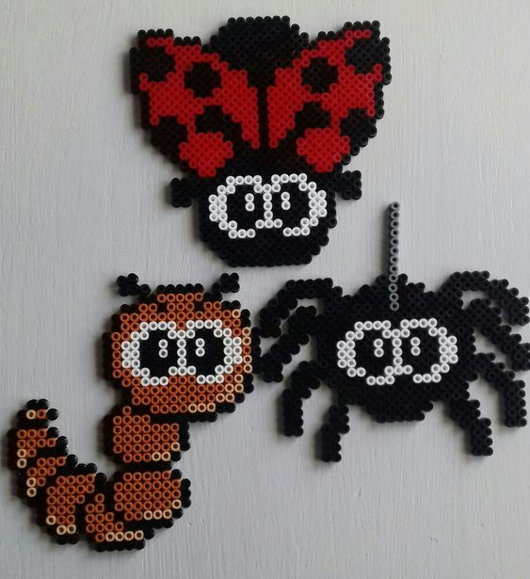
titre
 | a | b | c | d | e | f | g | h | i | j | k | l | m | n | o | p | q | r | s | t
1
2
3
4
5
6
7
8
9
10
11
12
13
14
15
16
17
18
19
20
21
22
23
24
25
26
27
28
29
30
31
32
33
34
titre
 | a | b | c | d | e | f | g | h | i | j | k | l | m | n | o | p | q | r | s | t
1
2
3
4
5
6
7
8
9
10
11
12
13
14
15
16
17
18
19
20
21
22
23
24
25
26
27
28
29
30
31
32
33
34

titre
 | a | b | c | d | e | f | g | h | i | j | k | l | m | n | o | p | q | r | s | t
1
2
3
4
5
6
7
8
9
10
11
12
13
14
15
16
17
18
19
20
21
22
23
24
25
26
27
28
29
30
31
32
33
34
titre
 | a | b | c | d | e | f | g | h | i | j | k | l | m | n | o | p | q | r | s | t
1
2
3
4
5
6
7
8
9
10
11
12
13
14
15
16
17
18
19
20
21
22
23
24
25
26
27
28
29
30
31
32
33
34

