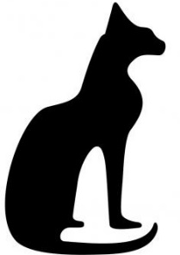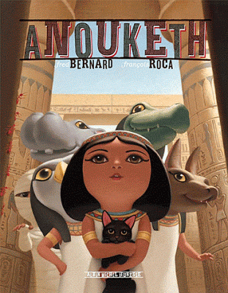Anouketh

1

François Roca et Fred Bernard

|  |  |  |  |  |  |  |  |  |  |  |  |  |  |  |  |
| --- | --- | --- | --- | --- | --- | --- | --- | --- | --- | --- | --- | --- | --- | --- | --- |
|  | |  | | | | est | | en | | . | |  | |  | |
|  | Ses | |  | | sont | | . | |  | |  | |  | |
|  | | Ils | | lui | | : | |  | |  | |  | |  | |
|  | | « Allons | | nous | | . » | | | |  | |  | |  | |

|  |  |  |  |  |  |  |
| --- | --- | --- | --- | --- | --- | --- |
|  | Anouketh | est | en | colère. |  |  |

|  |  |  |  |  |  |  |  |
| --- | --- | --- | --- | --- | --- | --- | --- |
|  | Ses | amis | sont | inquiets. |  |  |  |

|  |  |  |  |  |  |  |  |
| --- | --- | --- | --- | --- | --- | --- | --- |
|  | Ils | lui | disent : |  |  |  |  |

|  |  |  |  |  |  |  |
| --- | --- | --- | --- | --- | --- | --- |
|  | « Allons | nous | promener. » |  |  |  |

Anouketh

2

François Roca et Fred Bernard

|  |  |  |  |  |  |  |  |
| --- | --- | --- | --- | --- | --- | --- | --- |
|  |  | : | c’est | le | ? |  |  |
|  |  | : | c’est | le | ? |  |  |
|  | La |  | : | c’est | les | ? | |
|  |  | : | c’est | tes | ? | |  |

|  |  |  |  |  |  |  |  |
| --- | --- | --- | --- | --- | --- | --- | --- |
|  | Sobek | dit : | c’est | le | sport ? |  |  |

|  |  |  |  |  |  |  |  |
| --- | --- | --- | --- | --- | --- | --- | --- |
|  | Anubis | dit : | c’est | le | calcul ? |  |  |

|  |  |  |  |  |  |  |
| --- | --- | --- | --- | --- | --- | --- |
|  | La | momie | dit : | c’est | les | sciences ? |

|  |  |  |  |  |  |  |
| --- | --- | --- | --- | --- | --- | --- |
|  | Touéris | dit : | c’est | tes | parents ? |  |

Anouketh

3

François Roca et Fred Bernard

|  |  |  |  |  |  |  |  |
| --- | --- | --- | --- | --- | --- | --- | --- |
|  |  | | est | au | bord | du | . |
|  | Elle | est | en | . |  |  |  |
|  | Sa |  | va | avoir | un | . |  |
|  |  | |  | dans | le | . |  |

|  |  |  |  |  |  |  |
| --- | --- | --- | --- | --- | --- | --- |
|  | Anouketh | est | au | bord | du | Nil. |

|  |  |  |  |  |  |  |  |
| --- | --- | --- | --- | --- | --- | --- | --- |
|  | Elle | est | en | colère. |  |  |  |

|  |  |  |  |  |  |  |  |
| --- | --- | --- | --- | --- | --- | --- | --- |
|  | Sa | maman | va | avoir | un | bébé. |  |

|  |  |  |  |  |  |  |
| --- | --- | --- | --- | --- | --- | --- |
|  | Anouketh | tombe | dans | le | Nil. |  |

Anouketh

4

François Roca et Fred Bernard

|  |  |  |  |  |  |  |  |
| --- | --- | --- | --- | --- | --- | --- | --- |
|  |  | | va | se | ! |  |  |
|  | Son |  | . |  |  |  |  |
|  | Ils |  |  | la |  | d’. | |
|  |  | | se | sent | . |  |  |

|  |  |  |  |  |  |  |
| --- | --- | --- | --- | --- | --- | --- |
|  | Anouketh | va | se | noyer ! |  |  |

|  |  |  |  |  |  |  |  |
| --- | --- | --- | --- | --- | --- | --- | --- |
|  | Son | père | arrive. |  |  |  |  |

|  |  |  |  |  |  |  |
| --- | --- | --- | --- | --- | --- | --- |
|  | Ils | rentrent | voir | la | maman | d’Anouketh. |

|  |  |  |  |  |  |  |
| --- | --- | --- | --- | --- | --- | --- |
|  | Anouketh | se | sent | bien. |  |  |

|  |  |  |  |  |  |  |  |
| --- | --- | --- | --- | --- | --- | --- | --- |
|  |  |  |  |  |  |  |  |
| Anouketh | ami | inquiet | dire | promener | sport | calcul | sciences |
|  |  |  |  |  |  |  |  |
| parents | Sobek | Anubis | momie | Touéris | colère | maman | bébé |
|  |  |  |  |  |  |  |  |
| tombe | Nil | père | arriver | rentrer | voir | bien | noyer |
|  |  |  |  |  |  |  |  |
|  |  |  |  |  |  |  |  |