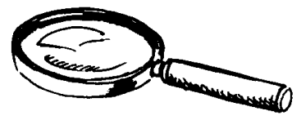
lecture-discrimination visuelle
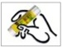

Colle les lettres pour écrire le mot.

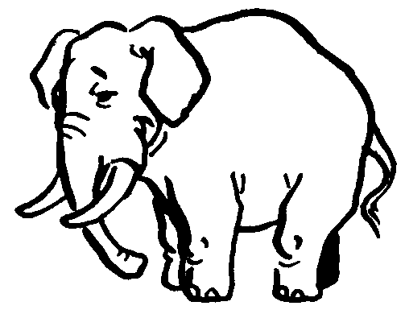 |  | 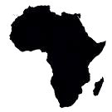
ELEPHANT |  | AFRIQUE

E | L | E | P | H | A | N | T

A | F | R | I | Q | U | E

---------------------------------------------------------------------------------------------------------------------
e | b | h | a | a | q | f | c | u
l | e | p | n | t | i | r | d | a

lecture-discrimination visuelle

Colle les lettres pour écrire le mot.

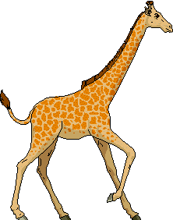 |  | 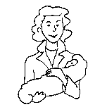
GIRAFE |  | MAMAN

G | I | R | A | F | E

M | A | M | A | N

---------------------------------------------------------------------------------------------------------------------
G | I | F | F | E | H | A | N | J
E | R | A | G | M | A | M | I | K

lecture-discrimination visuelle

Colle les lettres pour écrire le mot.

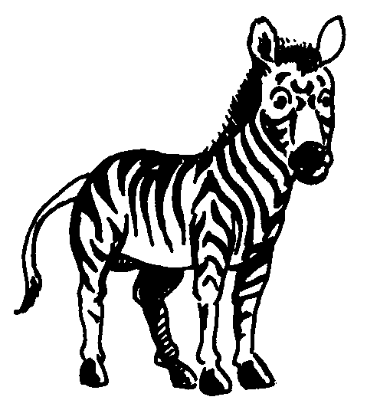 |  | 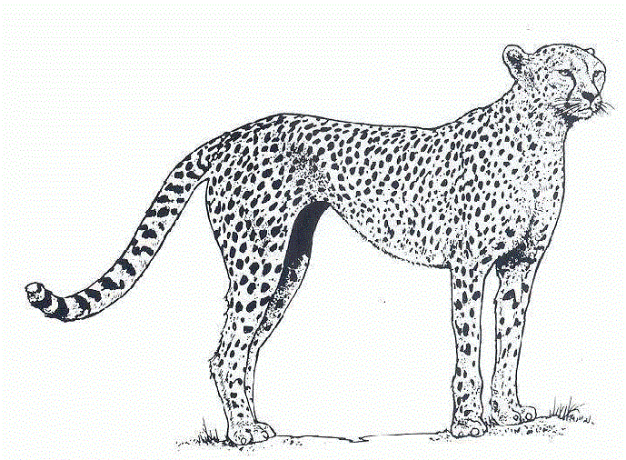
ZEBRE |  | GUEPARD

Z | E | B | R | E

G | U | E | P | A | R | D

---------------------------------------------------------------------------------------------------------------------
l | z | é | o | p | u | e | r | d
m | e | b | r | e | g | p | a | q

lecture-discrimination visuelle

Colle les lettres pour écrire le mot.

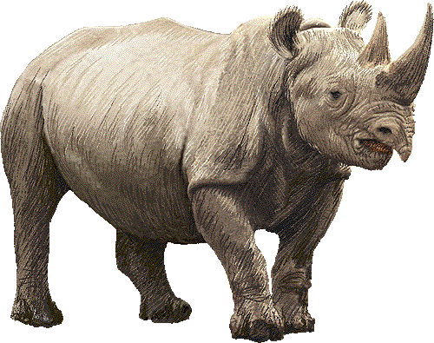 |  | 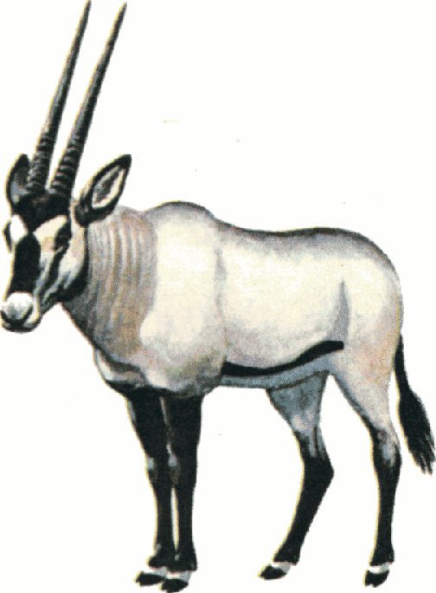
RHINOCEROS |  | ORYX

R | H | I | N | O | C | E | R | O | S

O | R | Y | X

---------------------------------------------------------------------------------------------------------------------
r | h | s | c | e | s | o | x | t | u | x
r | i | n | o | r | o | r | y | v | w | y

